Looney Tunes

“Looney Tunes” was an American animated comedy series produced by Warner Bros. between 1930 and 1969. It was known for introducing many cartoon characters. Here are some of them:

English | Portuguese | Description
Bugs Bunny | Pernalonga | He is the smartest and most cunning of all the characters. He always comes out well in the end.
Daffy Duck | Patolino | He is greedy and always wants more money. His ideas are usually crazy.
Speedy Gonzales | Ligeirinho | His motto is "The Fastest Mouse in all Mexico". He speaks with an exaggerated Mexican accent. He wears a yellow sombrero, white shirt and trousers, which used to be traditional clothes for men and boys in rural Mexico.
Sylvester | Frajola | A bad, selfish, despicable and useless cat. But he thinks he is cool! He always tries to catch Tweety, and usually fails.
Tweety | Piu-Piu | A sweet, blue-eyed canary. He is only a baby, but he is very intelligent and usually outwits Sylvester.
Hector the Bulldog | Hector, o Bulldog | Hector guards Tweety when Sylvester is around.
Road Runner | Papa-Léguas | The fastest ground bird in Texas and he is always chased by Wile E. Coyote.
Wile E. Coyote | Wile E. Coyote | He always tries to catch the Road Runner, but is never successful. He uses absurdly complex devices which always backfire, and he often gets injured. He always orders the devices from a company called “Acme”.
Elmer Fudd | Hortelino Troca-Letras | He is a hunter that chases Bugs Bunny and Daffy Duck, but he usually ends up injuring himself. When he speaks, he replaces his Rs and Ls with Ws, for example: "Shhh - be vewy vewy quiet, I'm hunting wabbits".
Granny | Vovó | An old woman who owns Tweety and Sylvester.
Marvin the Martian | Marvin, o Marciano | Marvin is a Martian who wants to destroy the Earth. His design was based on the Roman god Mars.
Yosemite Sam | Eufrazino | A gunslinger from the Wild West whose main rival is Bugs Bunny.
Porky Pig | Gaguinho | A stammering pig who usually appears with Daffy Duck or Bugs Bunny.
Pepé Le Pew | Pepé Le Pew | Pepé Le Pew is a French skunk who speaks with an exaggerated French accent. He has a bad smell and demonstrates exaggerated romanticism.

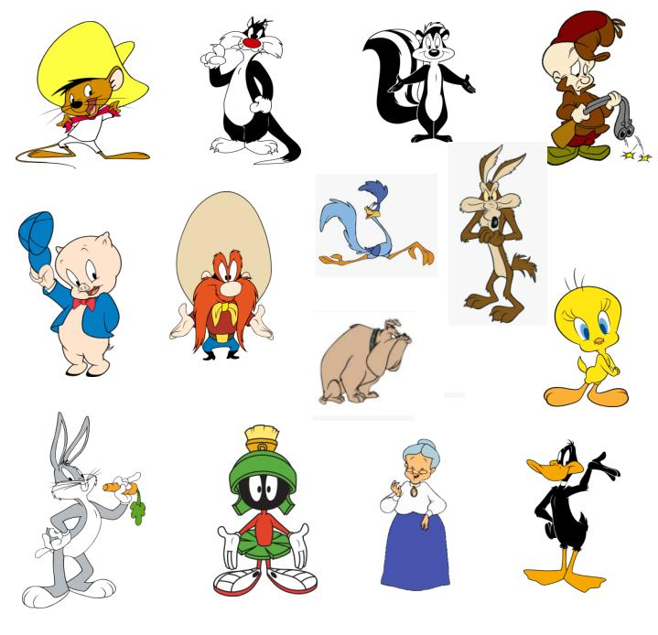
Exercise. Identify the cartoon characters:

